Power BI Assignment-1—R.SASIKALA
Import Data:
Import “List of Orders.csv” into Power BI.

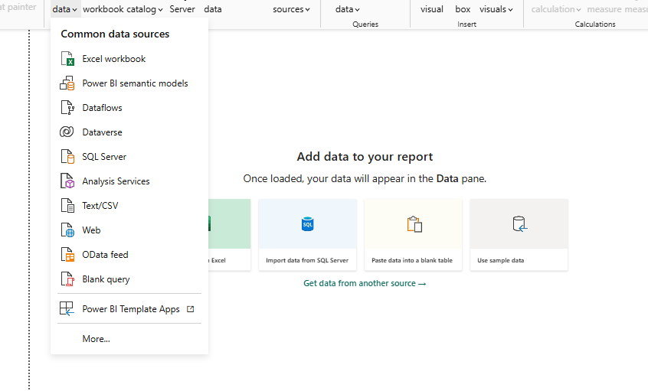

Open “List of Orders” in Power Query Editor by clicking on ‘Transform’.
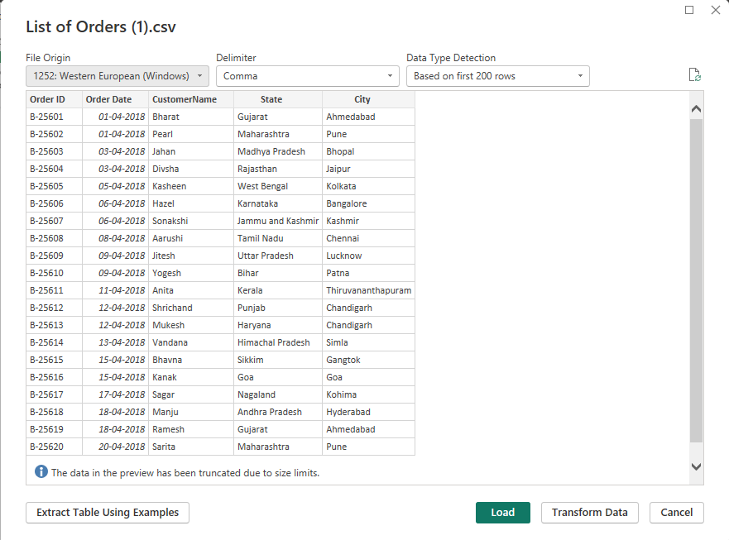

Power BI – Get data – Import for Text/CSV File – Transform the List of Order.csv – Transform to Power Query Editor

Import “Order Details.csv” and “Sales target.csv” into Power Query Editor
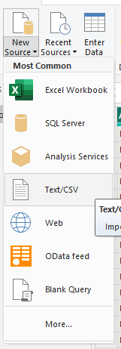
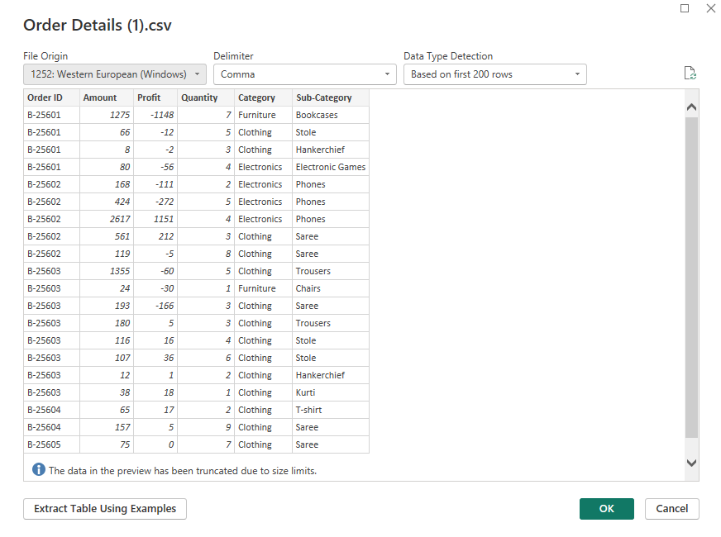
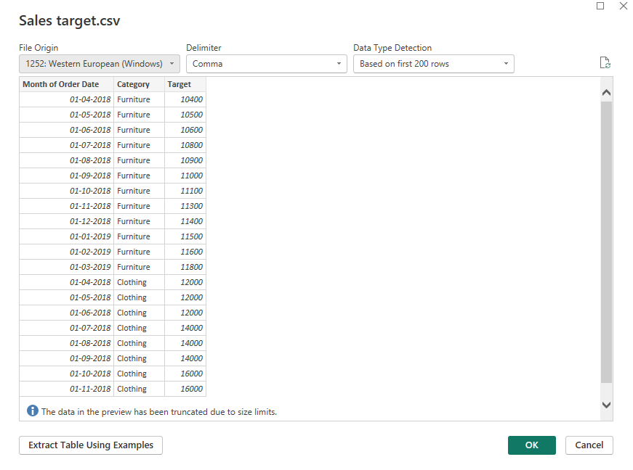
Power Query Editor – New source – get Text/ CSV File – Order Details table – Sales target table

Data Transformation:
Restrict the "List of Orders" table to only the first 500 rows.
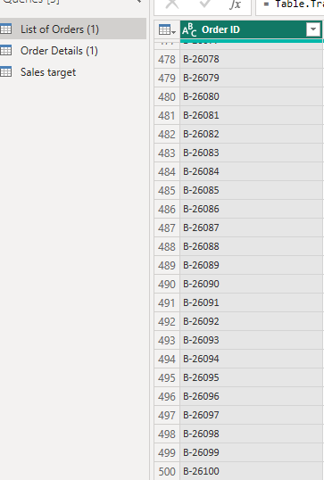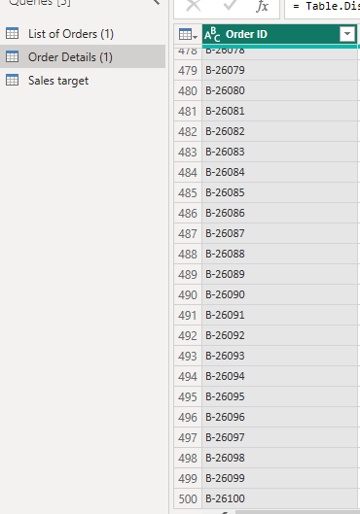

Ensure the “Order Date” column in the “List of Orders” table is set to data type 'Date'.

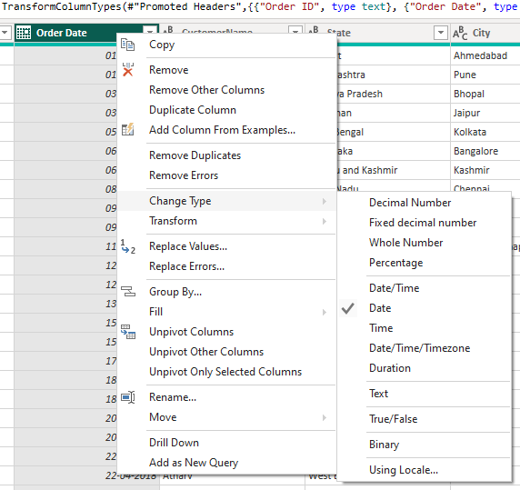
Order Date – Right click - Change Type - Date

Change the data type of “Amount” and “Target” columns to ‘Fixed Decimal Number’.
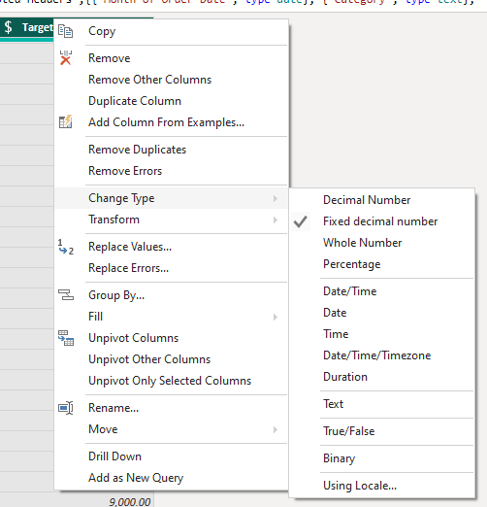

Target – Right Click - Change Type – Fixed decimal number
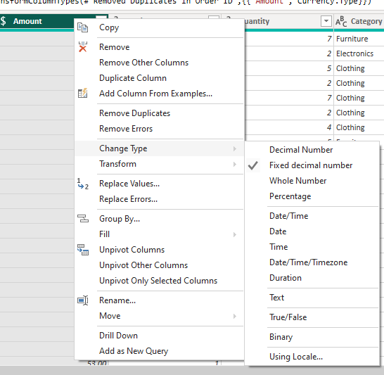

Amount – Right Click – Change Type – Fixed decimal number

Format the "CustomerName" column into proper case, ensuring consistent capitalization for each word.

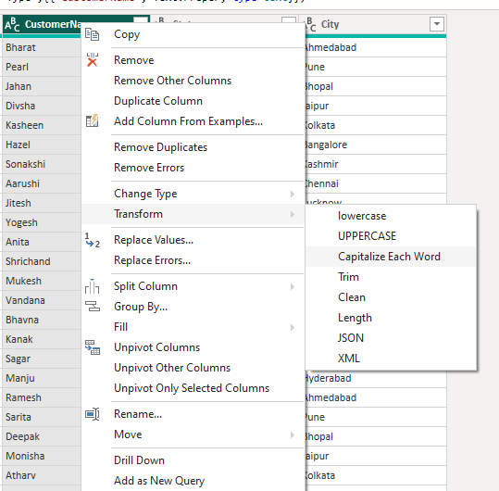

Merge the "State" and "City" columns to create a new column named "Location" in the format ‘City, State’.
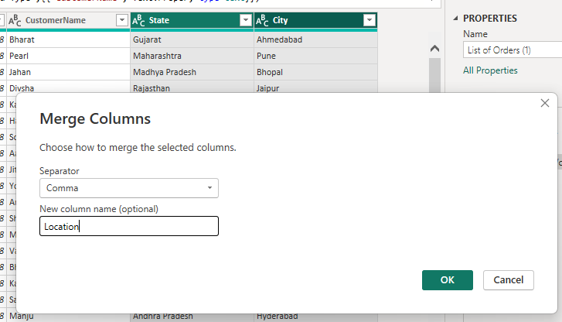

To Select State and City – Merge Column – Separator Comma – New Column Name – Location

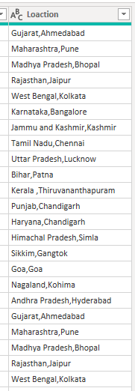

Create a new custom column named "Profit Margin" as the percentage of "Profit" divided by "Amount".

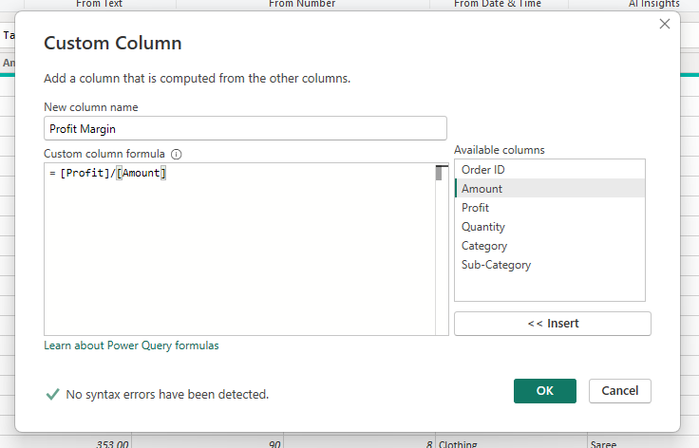
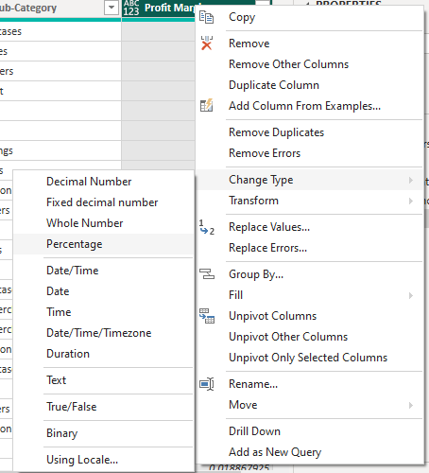

Add column – Custom Colum – New Column Name – Profit Margin – Conditional apply – Select Profit – insert – Divided – select Amount – OK
Create Profit Margin Column – Change Type – Percentage

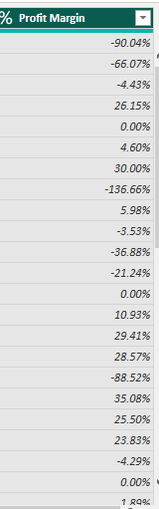

Add a new conditional column named "Profit Status" based on the values in the "Profit" column. The conditions are as follows: if the profit is less than 0, the label should be "Loss"; if the profit equals 0, the label should be "Break-Even"; and if the profit is greater than 0, the label should be "Profit".
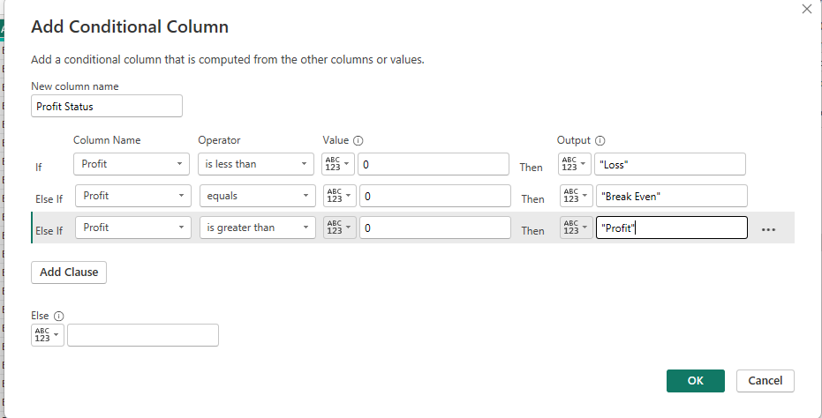
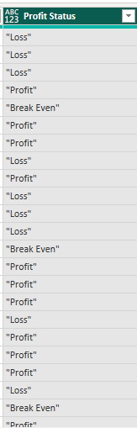

Add Column – Conditional Column – New Column Name – Profit Status – IF – Less than 0 – “Loss” – IF – Equal to 0 – “Break Even “- IF – Greater than 0 – “Profit” – New Column Created Name As Profit Status.

Merging Data (Joins):
Merge the "List of Orders" and "Order Details" tables into a new single table named "Orders Data" based on the "Order ID" relationship.
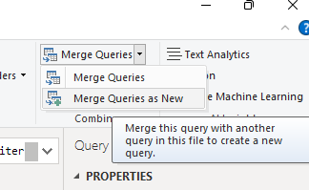
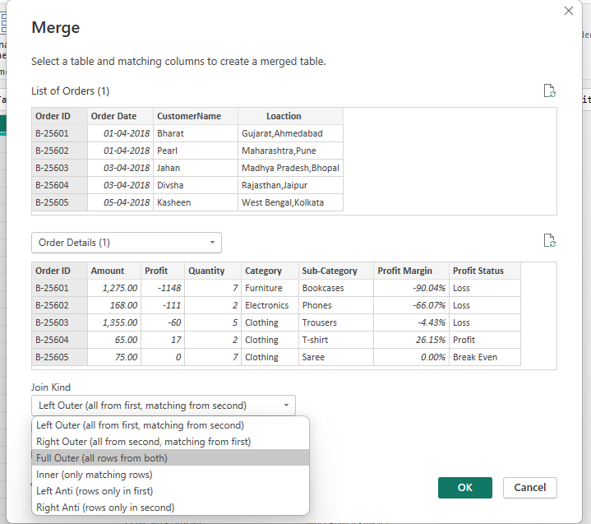
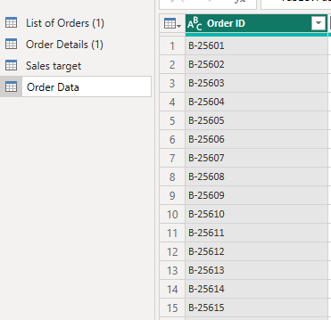
Merge Queries – Merge Queries New – Select Table1 –List Of Order – Select Table2 – Order Details – select Common Column in Table2 & Table2 – select Order ID – Select Full Outer – Created New Table – Name is Order Data.

Handling Missing Data & Duplicate Data:
Identify missing values in the data and determine a strategy to address them.
Check for duplicate rows and define a strategy to handle duplicates.
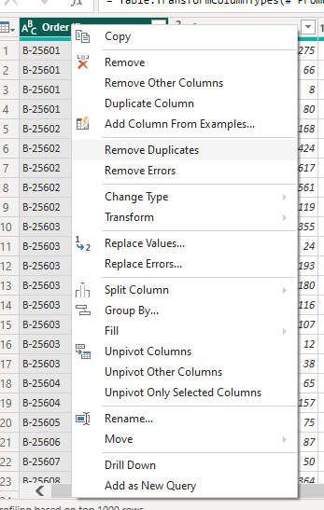

Select Order ID – Right Click – Remove Duplicates.

Sorting and Filtering Data:
In the ‘Orders Data’ table, utilize sorting and filtering techniques on columns like Order Date, State or Category to analyse data based on specific criteria:
Sort the orders by Order Date in descending order to analyse recent trends.
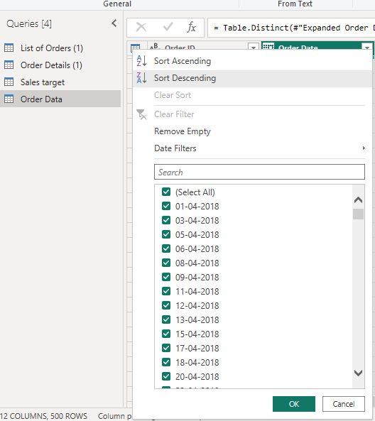
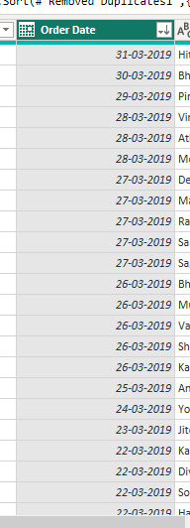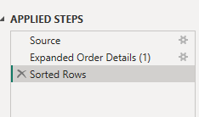

Select Order Data Table – select Date – Right Click – Select Descending Order – OK – Create Descending Order.
Filter the orders to focus only on a specific state (e.g., Tamil Nadu) for regional analysis.
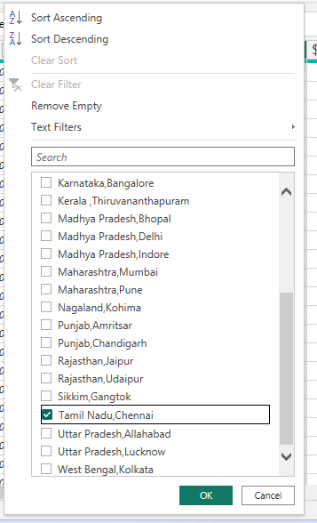

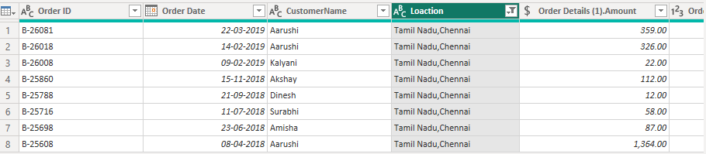

Select Location Column – Filter using select Tamil Nadu – Display the Tamil Nadu Details.

Grouping and Aggregating Data:
Duplicate the “Order Details” table and calculate the count of each Order ID

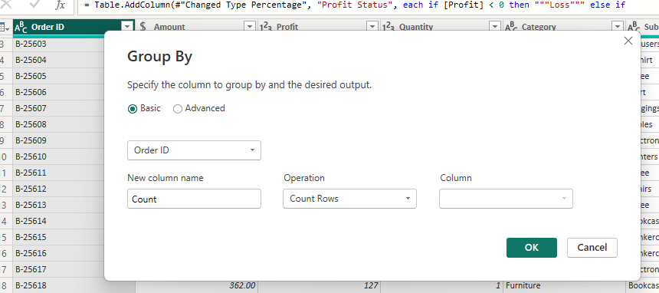
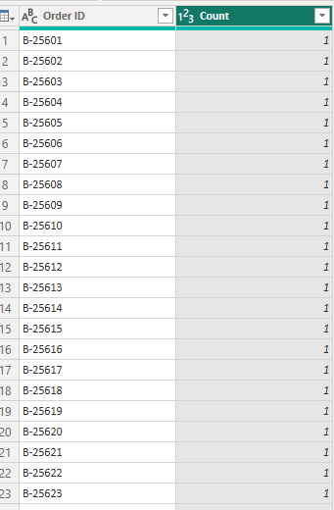

Select Group by – Order ID – Count New Column Name – Operation – Count Rows - OK

Average profit by Category:

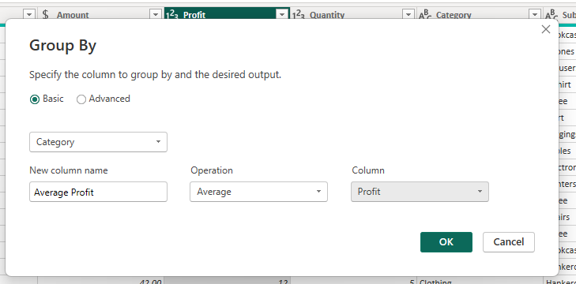

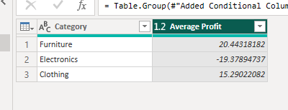

Select Group by – Select Category – New Column Name is Average Profit – Operation is Average – Column is Profit – OK – Display the Category wise Average Profit.

Total amount by Sub-Category.
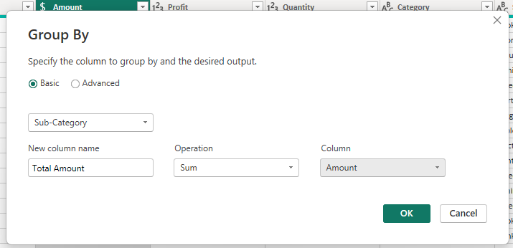
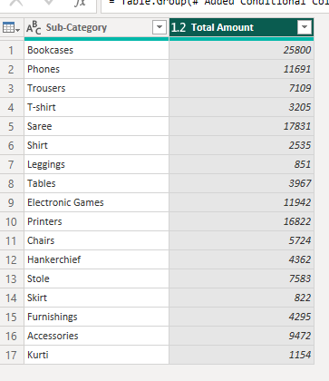

Select Group by – Select Sub-Category – New Column Name is Total Amount – Operation is Sum – Column is Amount – OK – Display the Sub- category wise Total Amount .

Duplicate the “Sales Target” table and aggregate the total target amount by Month of Order Date.

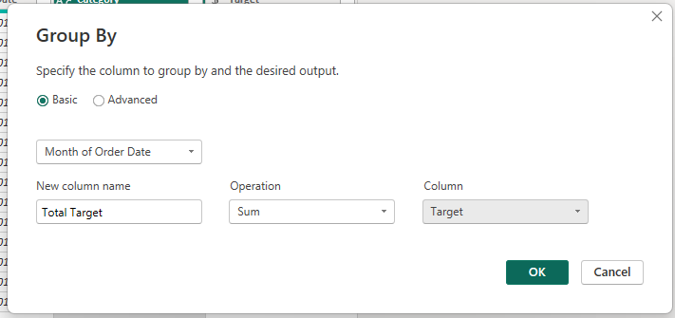
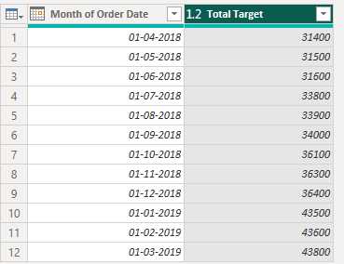

Select the Group by – Select Month of Order Date – New Column Name is Total Target – Operation is sum – Column is Target – OK – Display Month of Order Date wise Total Target.

Data Modelling:
Establish a relationship between the “List of Orders” and “Order Details” tables using the ‘Order ID’ column.
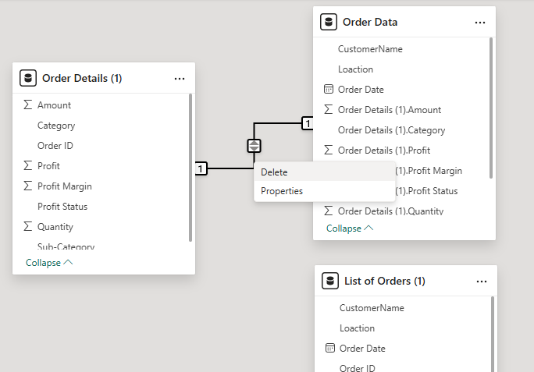
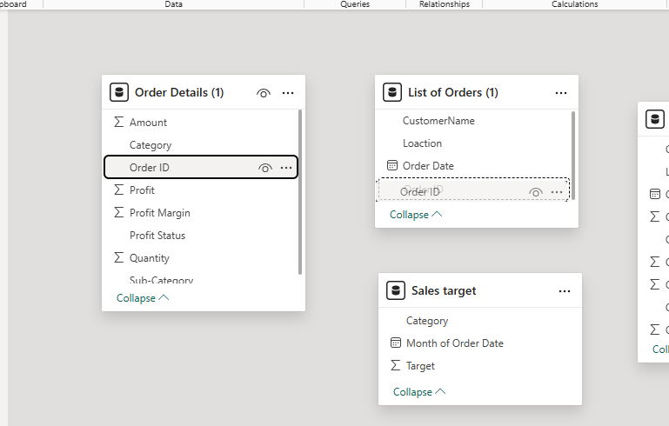
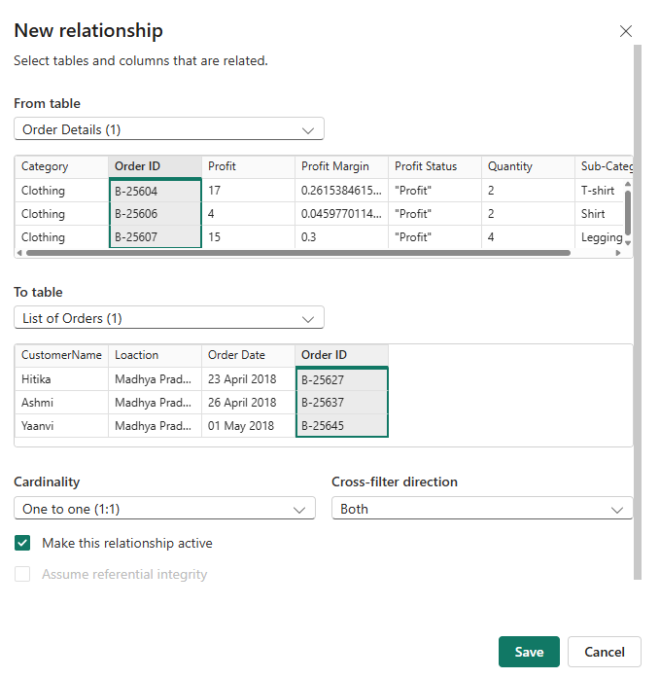
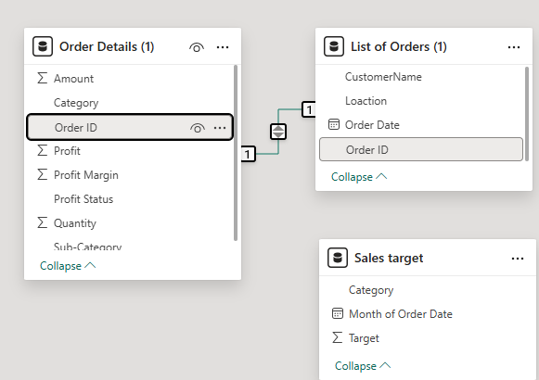

Power BI Close &Apply – Data Modelling – Delete the Pervious connect – Find Same Column Order ID - connect the Order Details Table &List Of Order Order ID Drag &Drop – connection built.

Build a relationship between the “Order Details” and “Sales Target” tables based on the ‘Category’ column. Click "Manage relationships"

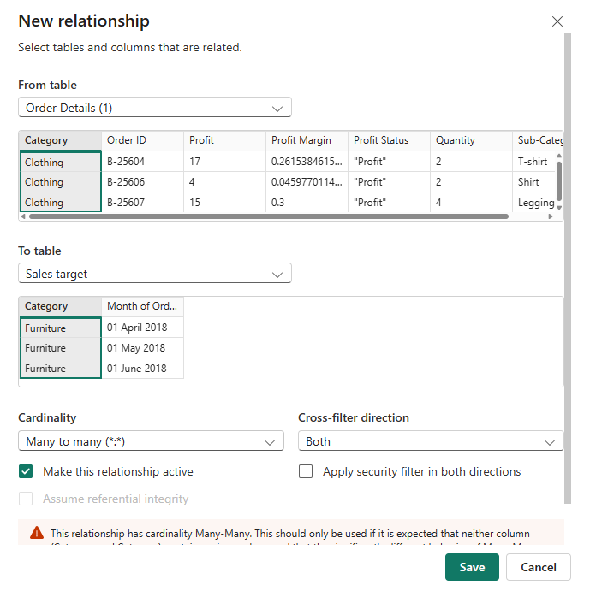
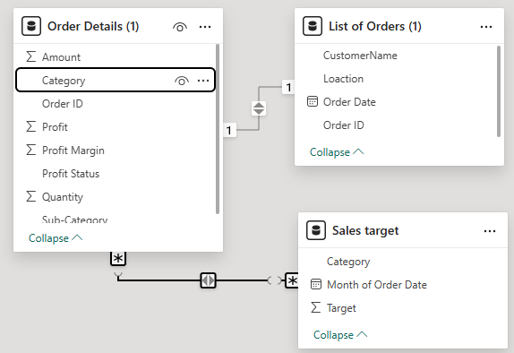
Find Same Column Category- connect the Order Details Table & Sales Target Table Drag &Drop – connection built.

Ensure this relationship is active:
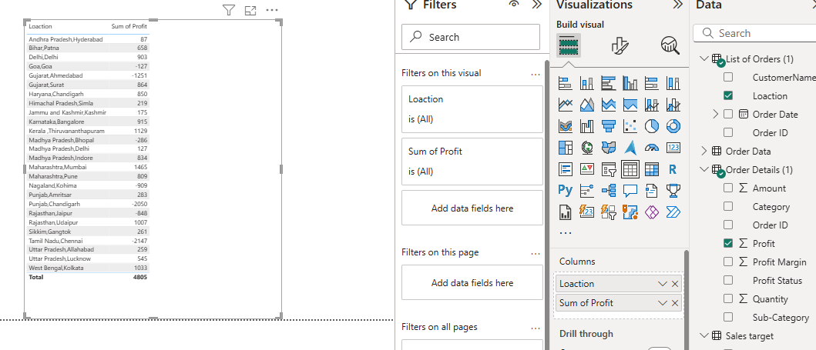

Select Table –find Location wise Profit connected.

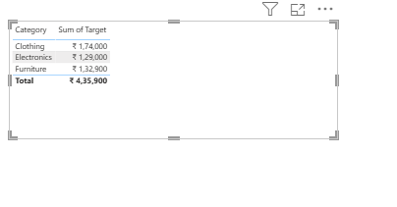
Find Category wise Target Connected

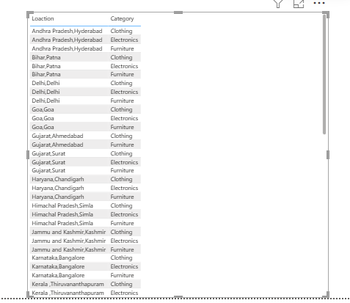

Find Location wise Category Connected

